ZOVI Fashion

By

Harjot Singh

Level-6

Final Project

Table of Contents

Project Proposal 3

Goals and Objectives 3

Project Scope 3

Project Specifications 3

Target Audience 3

Project Deliverables 4

Resource Requirements 4

Project Tasks and Milestones 4

Project Assumptions 5

Project Report 5

Detail Design 6

Home Page 6

Registration Page 6

Login Page 7

All Brands Admin View 7

Product Page Admin View 8

All Products Visitor View 8

All Brands Visitor View 9

Product Details Page Visitor View 9

Project Testing 10

User Manual 10

Summary 10

System Configuration 10

User Access Levels 10

# 

# Project Proposal

## Goals and Objectives

The main goal of the project is to implement an online web application named “ZOVI Fashion”. The main purpose of the application is help people to find best suitable garments from variety of brands and studio entries of latest trends. In this application there are two types of users- admin and registered user. Admin has different functionalities as compare to registered user. Admin can insert, edit, delete and check details of all studio stuff, products and their brands. Admin can edit, delete and check details of the product reviews. Also, admin can delete and access details of the reviews and brands.

## Project Scope

The scope of this project is to implement an app named “ZOVI Fashion” with the help of which user can find some clothing and review them. The duration of the project is 20 working days which is equals to 4 weeks.

## Project Specifications

* Admin login/logout
* Add, edit, delete and check details of product by admin.
* Admin can delete, edit and check clothing brands.
* Admin can delete and check studio for Application.
* Admin can register new admins.
* Registered Visitor can login/logout.
* New Visitor can register.
* Visitor can review the products.

## Target Audience

The target audience for this project is the fashion lover people who would love to enhance knowledge of latest trends and their fashion sense. The age can go from 18 plus to 80 plus.

## Project Deliverables

The deliverables of the project are as follows:

|  |  |
| --- | --- |
| **Deliverable** | **Description** |
| Final Report | This will be the final report of the project. |
| Coding | The executable code of the project will go under this. |
| Documentation | This portrays the documentation of the project. |
| Testing | All the test details will be covered in this part. |

## Resource Requirements

* Windows Operating System.
* Microsoft word for documentation.
* Asp.net MVC Framework
* 64-bit Processor and 8 GB or more RAM
* Identity framework- ASP

## Project Tasks and Milestones

|  |  |  |  |  |
| --- | --- | --- | --- | --- |
| **Tasks** | **Week-1** | **Week-2** | **Week-3** | **Week-4** |
| Brainstorming and analysis |  |  |  |  |
| Planning and initial meeting Project Proposal document. |  |  |  |  |
| Database Design and UI Design |  |  |  |  |
| Identity framework implementation |  |  |  |  |
| Coding for admin and reporter |  |  |  |  |
| Testing |  |  |  |  |
| Final Documentation and closing |  |  |  |  |

## Project Assumptions

Following are the assumption made while implementing the project:

* One admin and registered visitor will be registered by default.
* Application will be free and open source.

# Project Report

#### Functional and Non-Functional

|  |  |
| --- | --- |
| Users | Functional |
| Admin | * Login/logout * Register new admins * Admin can add, edit, delete, check details for brands. * Admin can edit, delete and check details for products. * Admin can delete and check details for the studio entries. |
| Customer | * Can view details of companies, product and studio entries. * Can review the product * New customers can register for free. * Login using valid credentials |
|  | Non- Functional |
|  | * High speed * Fast Loading time * High performance and security * All browsers compatibility. |

## 

## Detail Design

### Home Page

The main landing page of the application. On navigation bar options are- Home, All Companies, All Product, Studios, Register, Login.

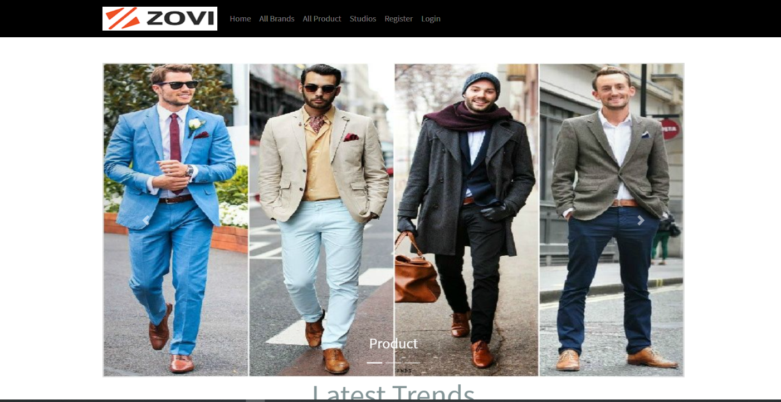

### 

### Registration Page

With the help of this page, new registered visitor can sign up for the app

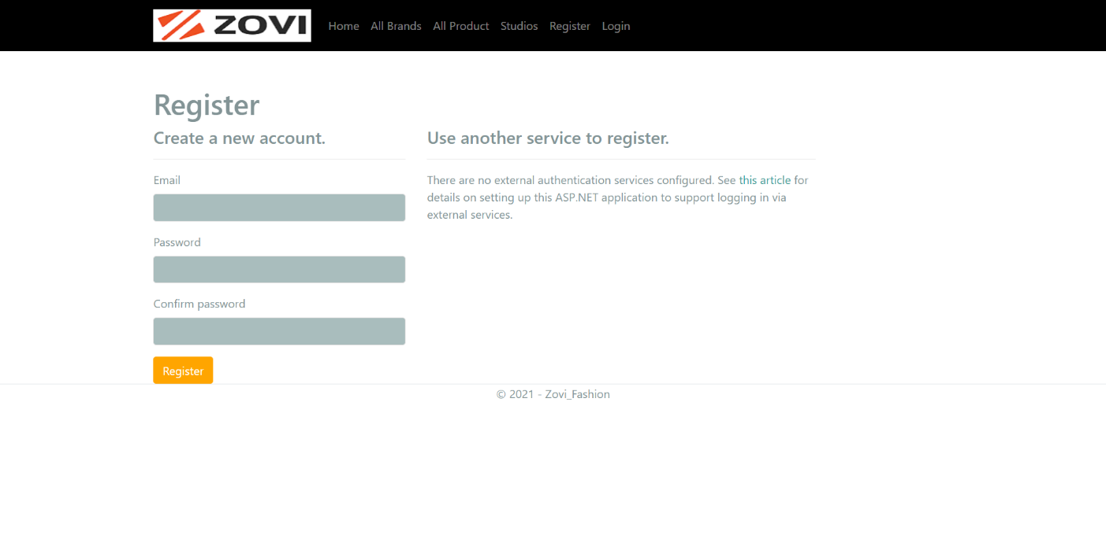

### Login Page

With the help of this page, registered visitor and admin can login to the application using their valid credentials.

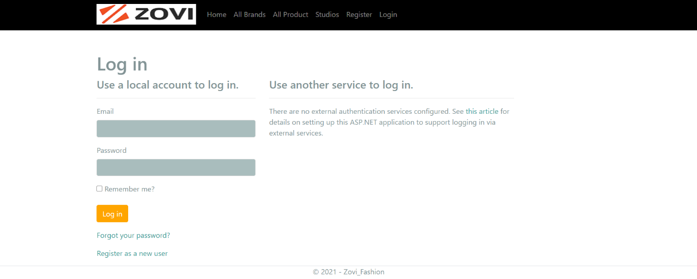

### All Brands Admin View

This page highlights all the Companies available on the application. Admin can add new Company, edit, delete and check details of the existing ones.

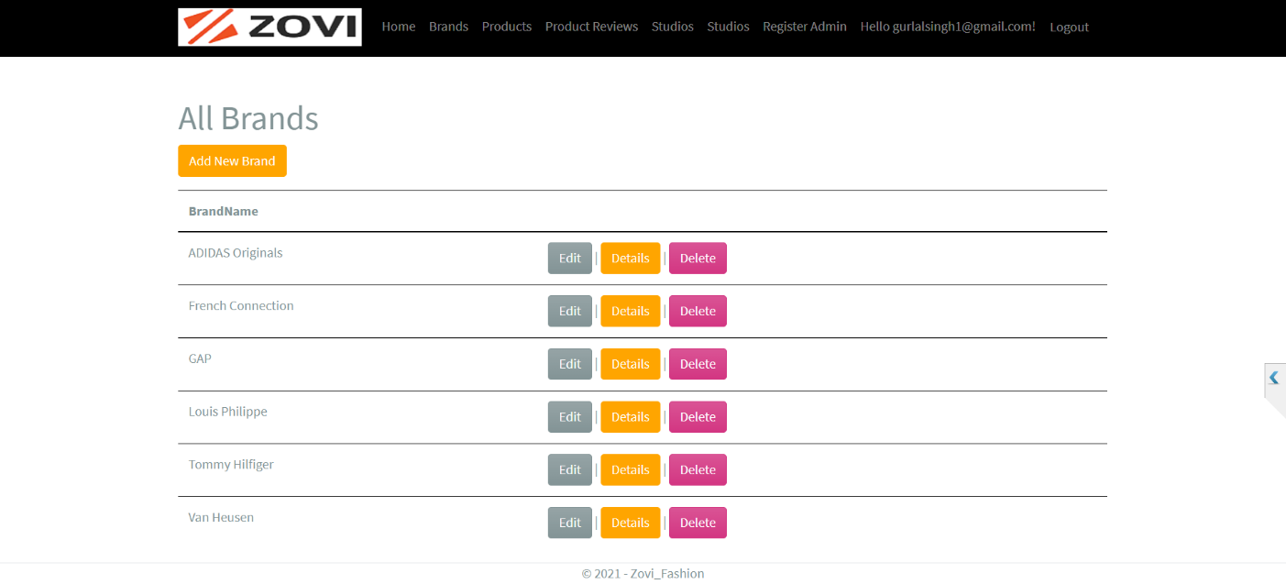

### 

### Product Page Admin View

With the help of this page admin can manage the products by editing, deleting and checking their details.

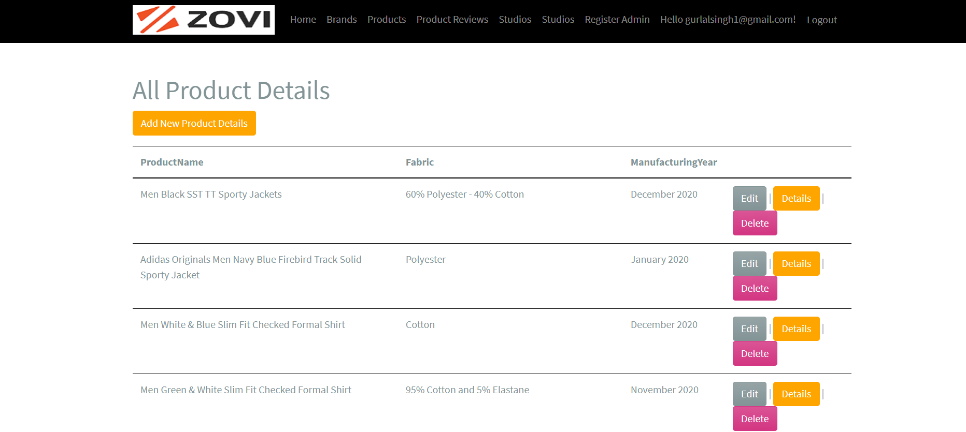

### Product Page Visitor View

With the help of this page Visitor can view Product details.

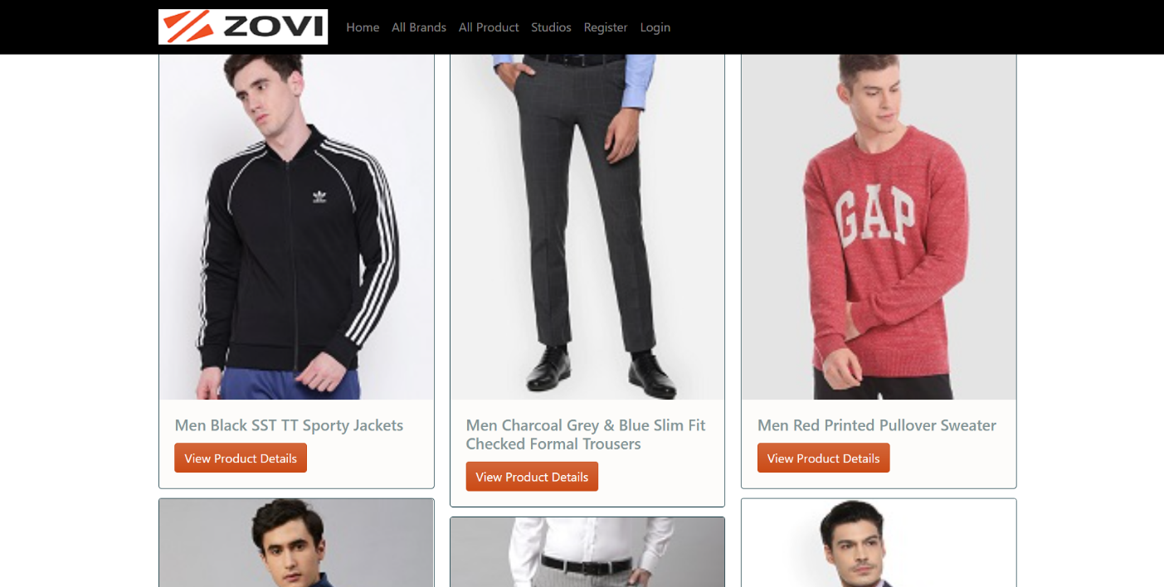

### All Brands Visitor View

With the help of this page visitor can check the details of the companies and their products.

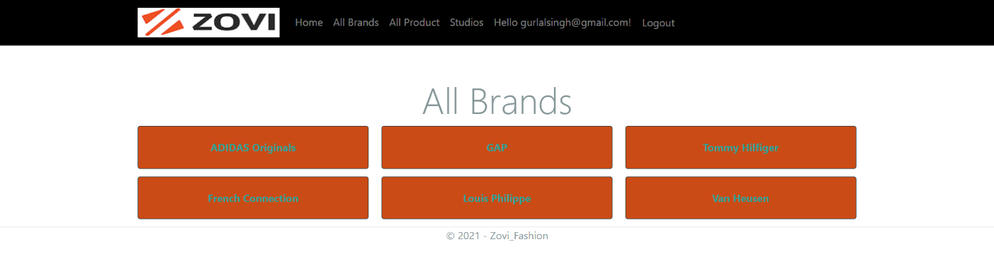

### Product Details Page Customer View

This page shows the Product details and pricing of the recipes.

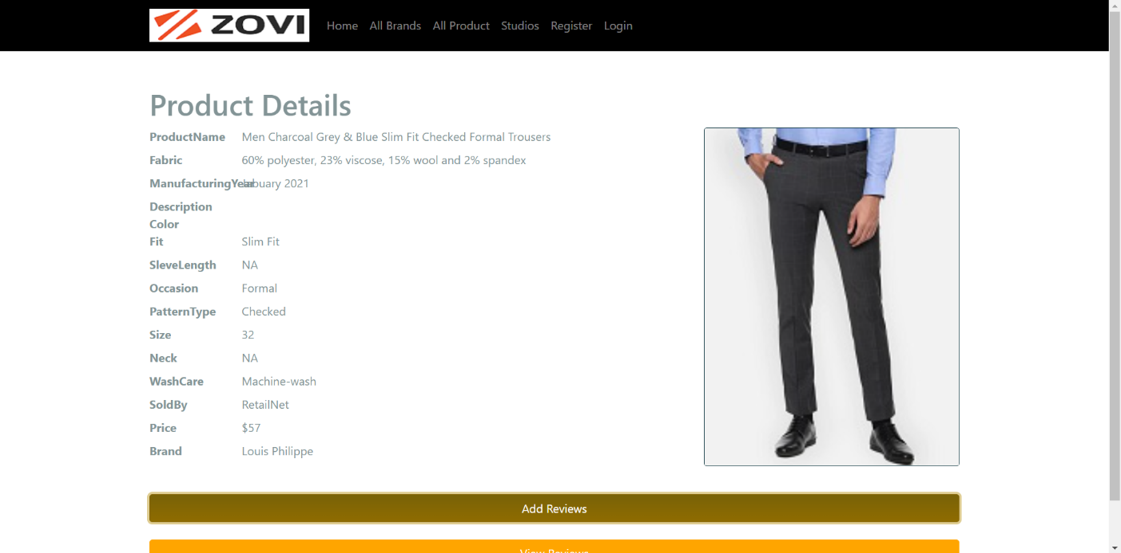

## Project Testing

The testing file for usability testing is attached as [usability test.xlsx](usability%20test.xlsx)

# User Manual

The main purpose of the application ZOVI Fashion is to help people to find product of their choice based upon other visitor review. In this application there are two types of users- admin and registered user or visitor customer. Admin has different functionalities as compare to customers. Admin can add, edit, delete and check details of companies, studio entries. Admin can edit, delete and check details of the companies, product and studio entries. Also, admin can delete, and access details of the review made by the visitor.

## Summary

### System Configuration

This app will be useful to for distributing product information in presentable format.

### User Access Levels

Only registered users can access the features of this application.

* **Admin:** Admin has full access of the app can register new admins.
* **Registered Visitor:** New visitor can register and existing can login using their own credentials. They have limited access.